Magrupsa Website User Manual

Introduction

The Magrupsa website is a Famagusta city (municipality) website that allows its user to carry out a few but very important functions with stunning easy and flexibility. The main functions of the website and how to go about using them will be discussed in this manual

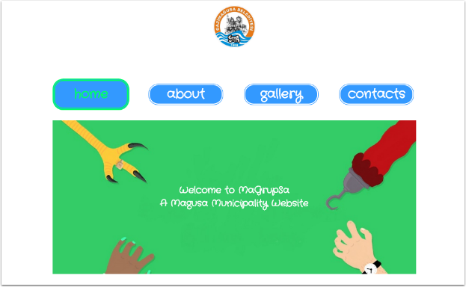

Main Menu

The main menu of the website provides users with the ability to navigate easily between pages since it stays present on each and every page you access. The main menu has the following buttons:

**Home:** To let you return to the home/welcome page

**About:** To let you access an about page that offers a brief information in the history of this beautiful city amongst other things

**Gallery:** To let you access pictures new and old of famagusta at its stunning best

**Contact:** To give you contact information on how to reach us or register complaints, questions and suggestion

Highlighting buttons allow you to keep track of your movement withing pages so you're never turned or lost while navigating the website

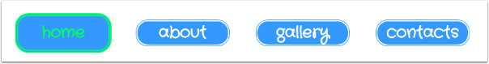

About

The about button on the main menu allows you access some history about the city of famagusta. This informative piece provided in the about will bring the cities past present and future into your perspective and make your experience of visiting or living in this harbor of culture all the more appealling. A link at the end of this briefy history allows you access a map of the city to help you with navigation. By clicking the link you will have access to this map.

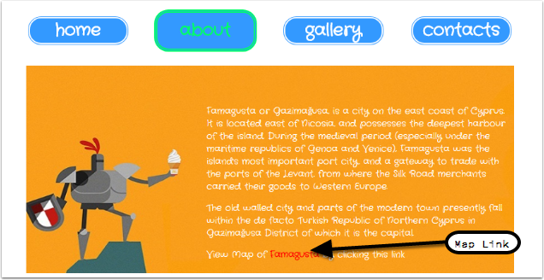

Gallery

The gallery is home to some of the most beautiful images of the city. It captures this majestic place at different times of the day and also in different eras to give you a sense of the transformation process that has occured. The gallery also offers its users the ability to tune into their patriotic side with a dedicated button for the national anthem.

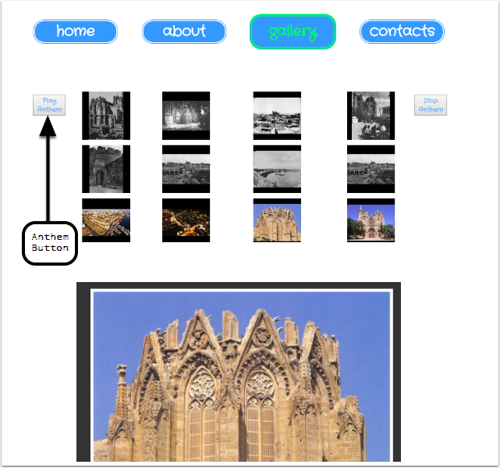

Contacts

The contact page of this website allows users to get in touch with us with quesstions, comments or suggestions. This feature is simply accessed by clicking the "send us an email" link. on the contact page.

It also provides a feedback page for users to tell us about their experience to further help us provide better for their needs. This feature is accesed by clicking the "feedback form" link on the contact page.

